

Architectural Risk Analysis

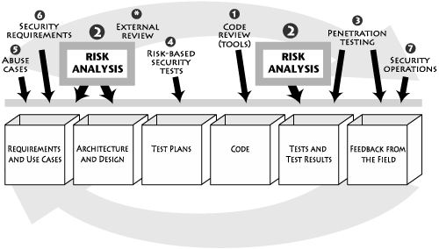Architectural Risk Analysis

Risk analysis approach
- Learn as much as possible about the target of analysis.
  - Read and understand the specifications, architecture documents,
and other design materials.
  - Discuss and brainstorm about the target with a group.
  - Determine system boundary and data sensitivity/criticality.
  - Play with the software (if it exists in executable form).
  - Study the code and other software artifacts (including the use of code analysis tools).
  - Identify threats and agree on relevant sources of attack (e.g., will
insiders be considered).

Risk analysis approach
- Discuss security issues surrounding the software.
  - Argue about how the product works and determine areas of disagreement or ambiguity.
  - Identify possible vulnerabilities, sometimes making use of tools or lists of common vulnerabilities.
  - Map out exploits and begin to discuss possible fixes.
  - Gain understanding of current and planned security controls.

Risk analysis approach
- Determine probability of compromise.
  - Map out attack scenarios for exploits of
vulnerabilities.
  - Balance controls against threat capacity to
determine likelihood.
- Perform impact analysis.
  - Determine impacts on assets and business goals.
  - Consider impacts on the security posture.

Risk analysis approach
- Rank risks.
- Develop a mitigation strategy.
  - Recommend countermeasures to mitigate risks.
- Report findings.
  - Carefully describe the major and minor risks, with attention to impacts.
  - Provide basic information regarding where to spend limited mitigation resources.

Risk Analysis in Practice
Two basic categories:
- Commercial: STRIDE from Microsoft, Security Risk Management Guide, also from Microsoft, ACSM/SAR (Adaptive Countermeasure Selection Mechanism/Security Adequacy Review) from Sun
- Standards-Based: ASSET (Automated Security Self- Evaluation Tool) from the National Institute on Standards and Technology (NIST) , OCTAVE (Operationally Critical Threat, Asset, and Vulnerability Evaluation) from SEI

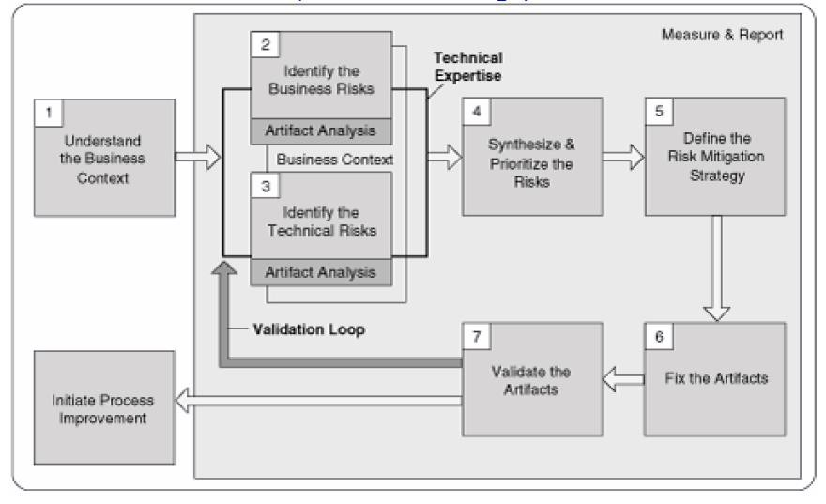Risk Analysis Fits in the RMF

Traditional Risk Analysis Terminology
  - Asset: A system component, data, or even a complete system.
  - Risk: The probability that an asset will suffer an event of a given negative impact.
  - Threat: The actor or agent who is the source of danger.

Traditional Risk Analysis Terminology
  - Vulnerability: In general, a vulnerability is a defect or weakness in system security procedures.
  - Countermeasures or safeguards: Technical controls prescribed for an information system which, taken together, adequately protect the confidentiality, integrity, and availability of the system and its information.

Traditional Risk Analysis Terminology
  - Probability: The likelihood that a given event will be triggered. Three simple buckets:
    - High (H)
    - Medium (M),
    - Low (L).

Threat Modeling versus Risk Analysis: Microsoft Redefines Terms
STRIDE is an acronym for
- Spoofing,
- Tampering,
- Repudiation,
- Information disclosure,
- Denial of service, and
- Elevation of privilege.
Source: Official Link

Architectural Risk Analysis

Risk Analysis (Requirements And Use Cases)

  - Missing Stakeholders
  - Wrong Stakeholders
  - Ambiguous Requirements
  - Incomplete Requirements
  - Conflicting Requirements
  - Infeasible Requirements
  - Unverifiable Requirements
  - Undocumented Assumptions
  - Invalid Assumptions
  - Inadequate Validation

Risk Analysis (Architecture And Design)

  - Design flaws account for 50% of security problems.
  - Some requirements are not specified properly.
  - Validation rules might be improper in requirement stage.
  - Designer should know about tools and languages.
  - Designer should be aware of known attacks.

Traditional Risk Calculation Approach

One classic risk-analysis method expresses risk as a financial loss, or
annualized loss expectancy, based on the following equation:
ALE = SLE × ARO
where SLE is the single loss expectancy and ARO is the annualized rate of occurrence.

For an example,
A event causes financial loss for ABC market. Let’s assign a cost of
$150 for any such event, so SLE = $150. With an ARO of just 100
such events per year, the cost to the company (or ALE) will be
$15,000.

Limitations of Traditional Approaches

  - In the case of a Web server providing a company's face to the world, a Web site defacement might be difficult to quantify as a financial loss.
  - Traditional risk analysis techniques do not necessarily provide an easy guide of all potential vulnerabilities and threats to be concerned about at a component level.

Source: Risk analysis in software design

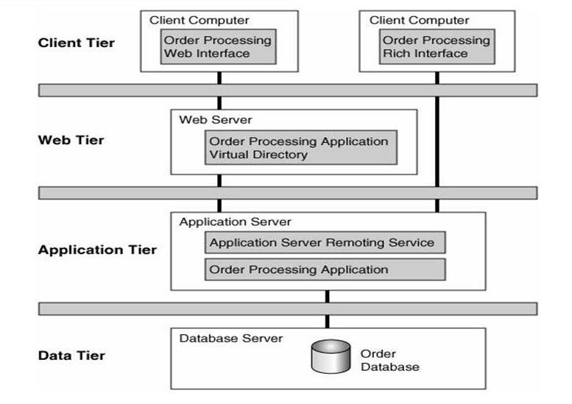A Basic Risk Analysis Approach

A Basic Risk Analysis Approach

During the risk analysis process one should consider…
  - The threats who are likely to attack our system.
  - The risks present in each tier's environment.
  - The kinds of vulnerabilities that might exist in each component, as well as the data flow.
  - The business impact of such technical risks, were they to be realized.
  - The probability of such a risk being realized.
  - Any feasible countermeasures that could be implemented at each
tier.

Touchpoint Process: Architectural Risk Analysis

  - A risk analysis should be carried out only once a reasonable, big-picture overview of the system has been established.
  - Thus the first step of the process shown in the figure is to build a one-page overview of the system under analysis. Sometimes a one-page big picture exists, but more often it does not.
  - The one-page overview can be developed through a process of artifact analysis coupled with interviews.

Touchpoint Process: Architectural Risk Analysis

Three critical steps (or sub-processes) make up the heart of this architectural risk analysis approach
- Attack resistance analysis
- Ambiguity analysis
- Weakness analysis

Attack Resistance Analysis
Four steps are involved in this sub-process
  - Identify general flaws using secure design literature and checklists (e.g., cycling through the Spoofing, Tampering, ... categories from STRIDE). A knowledge base of historical risks is particularly useful in this activity.
  - Map attack patterns using either the results of abuse case
development or a list of attack patterns.
  - Identify risks in the architecture based on the use of checklists.
  - Understand and demonstrate the viability of these known attacks
(using something like exploit graphs; see the Exploit Graphs box
).

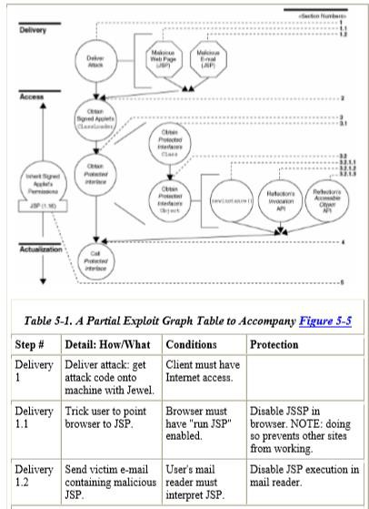Exploit Graphs box

Ambiguity Analysis
  - Ambiguity analysis helps to uncover ambiguity and inconsistency
  - Ambiguity analysis is the sub-process capturing the creative activity required to discover new risks
  - This process, by definition, requires at least two analysts (the more the merrier) and some amount of experience
  - this subprocess works best when carried out by a
team of very experienced analysts

Weakness Analysis
  - Weakness analysis is a sub-process aimed at understanding the impact of external software dependencies.
  - It can be happened in Frameworks, network topology
  - Example flaws
- Debug interfaces
- Unused (but privileged) product "features“
- Interposition attacks—DLLs, library paths, client spoofing



Architectural Risk Analysis Is a Necessity

Acknowledgement

  - Md. Eusha Kadir
  - Md. Aquib Azmain
  - Md. Nazmul Haque



Any Question?

Thank You.

